**UNIVERSITY OF RWANDA**

**COLLEGE OF SCIENCE AND TECHNOLOGY SCHOOL OF ICT**

**COMPUTER AND SOFTWARE ENGINEERING DEPARTMENT [NYARUGENGE CAMPUS/GAKO]**

**MODULE CODE/TITLE: INTERACTIVE WEB DEVELOPMENT**

1. **224008709**
2. **224006132**
3. **224004620**

**Year of study: 2**

**Date: 14/12/2025**

# Table of Contents

* 1. Chapter 1. Introduction - 4
* 2. Chapter 2. System Analysis and Design - 8
* 3. Chapter 3. Implementation - 20
* 4. Chapter 4. Conclusion and Recommendation - 35
* 5. Appendix - 36

# Chapter 1. Introduction

## 1.1 Historical Background of the Case Study

Healthcare service delivery has traditionally relied on face-to-face consultations, paper-based patient records, and fragmented communication between patients, healthcare providers, and health institutions. In many developing countries, including Rwanda, access to timely and specialized medical care has been significantly limited by geographical distance, shortage of healthcare professionals, long waiting times, and inefficient referral systems.  
  
AccessHealth is a web-based healthcare management platform designed to connect patients, doctors, and healthcare institutions through a unified digital solution. The platform aims to support hospitals, clinics, and independent healthcare providers by offering doctor discovery services, appointment scheduling, wearable device integration, and secure patient record management.

## 1.2 Problem Statement

Access to quality healthcare services remains a major challenge, particularly in developing countries where healthcare resources are limited and unevenly distributed. Many patients experience difficulties in finding appropriate medical specialists, booking appointments, and receiving timely medical advice. Long waiting times, lack of early symptom assessment, and poor coordination between healthcare providers often lead to delayed diagnosis and treatment.

## 1.3 Proposed Solution

AccessHealth is designed to address the identified challenges through a comprehensive digital healthcare platform that enables:

* Patient-Centric Services: Patients can easily discover qualified doctors and book appointments
* Integrated Health Records: Secure electronic patient records accessible to authorized professionals
* Real-Time Health Monitoring: Integration with wearable health devices for vital signs tracking
* Appointment Management: Streamlined appointment scheduling with automatic notifications
* Notification System: Real-time notifications for appointments, health alerts, and updates
* Doctor Management: Efficient schedule and patient record management for healthcare providers

# Chapter 2. System Analysis and Design

## 2.1 Database Design (Entity Relationship Diagram)

The AccessHealth system uses a relational database with the following core entities:

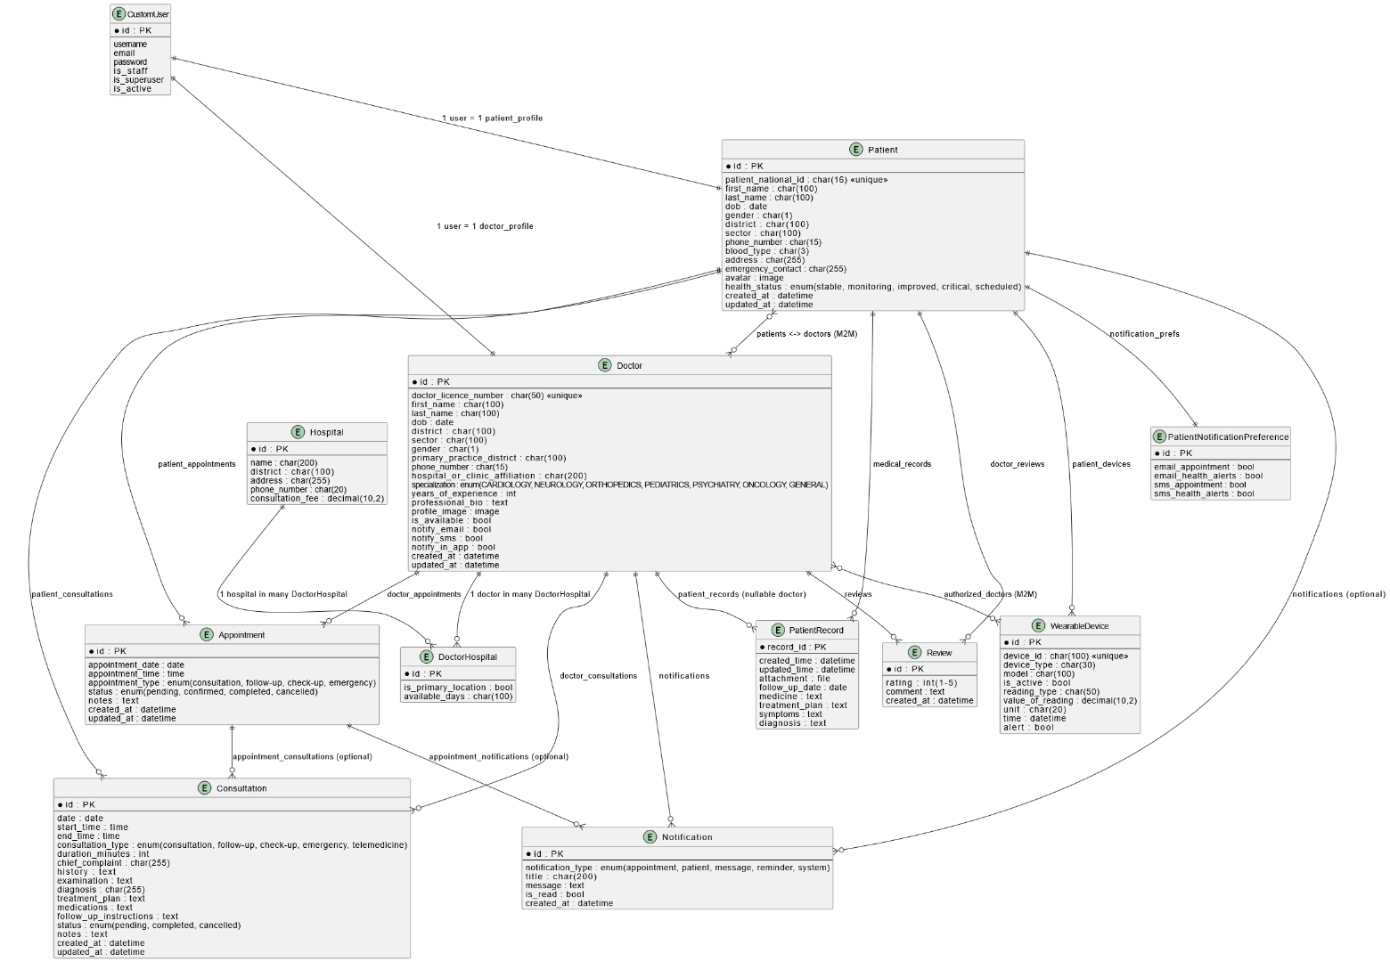

*Figure 1: Database Entity Relationship Diagram*

# Chapter 3. Implementation and Screenshots

## 3.1 Landing Page

The landing page serves as the entry point to AccessHealth, displaying system overview, key features, and call-to-action buttons.

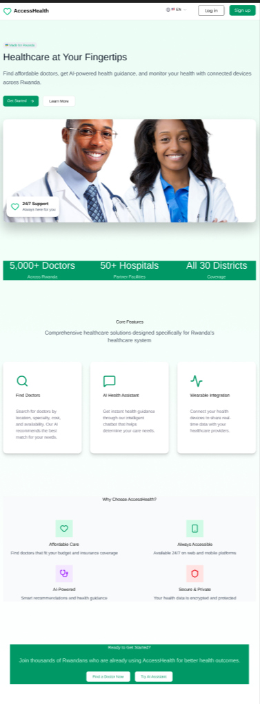

*Figure 2: AccessHealth Landing Page*

## 3.2 Patient Registration and Login

### Patient Login Page

The patient login interface provides email and password fields with comprehensive validation.

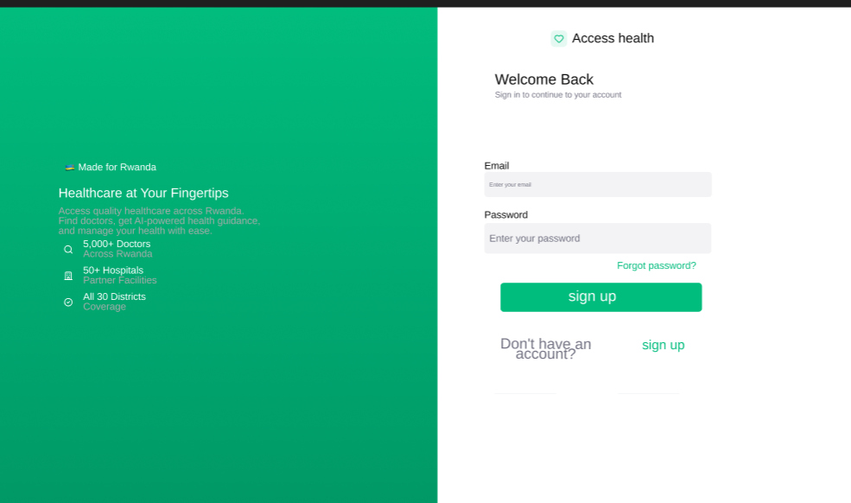

*Figure 3: Patient Login Page*

The login process includes multi-step verification:

* Email existence check (case-insensitive)
* Password authentication using Django's system
* Patient profile attribute verification
* Session creation and dashboard redirect

### Patient Login Authentication Flowchart

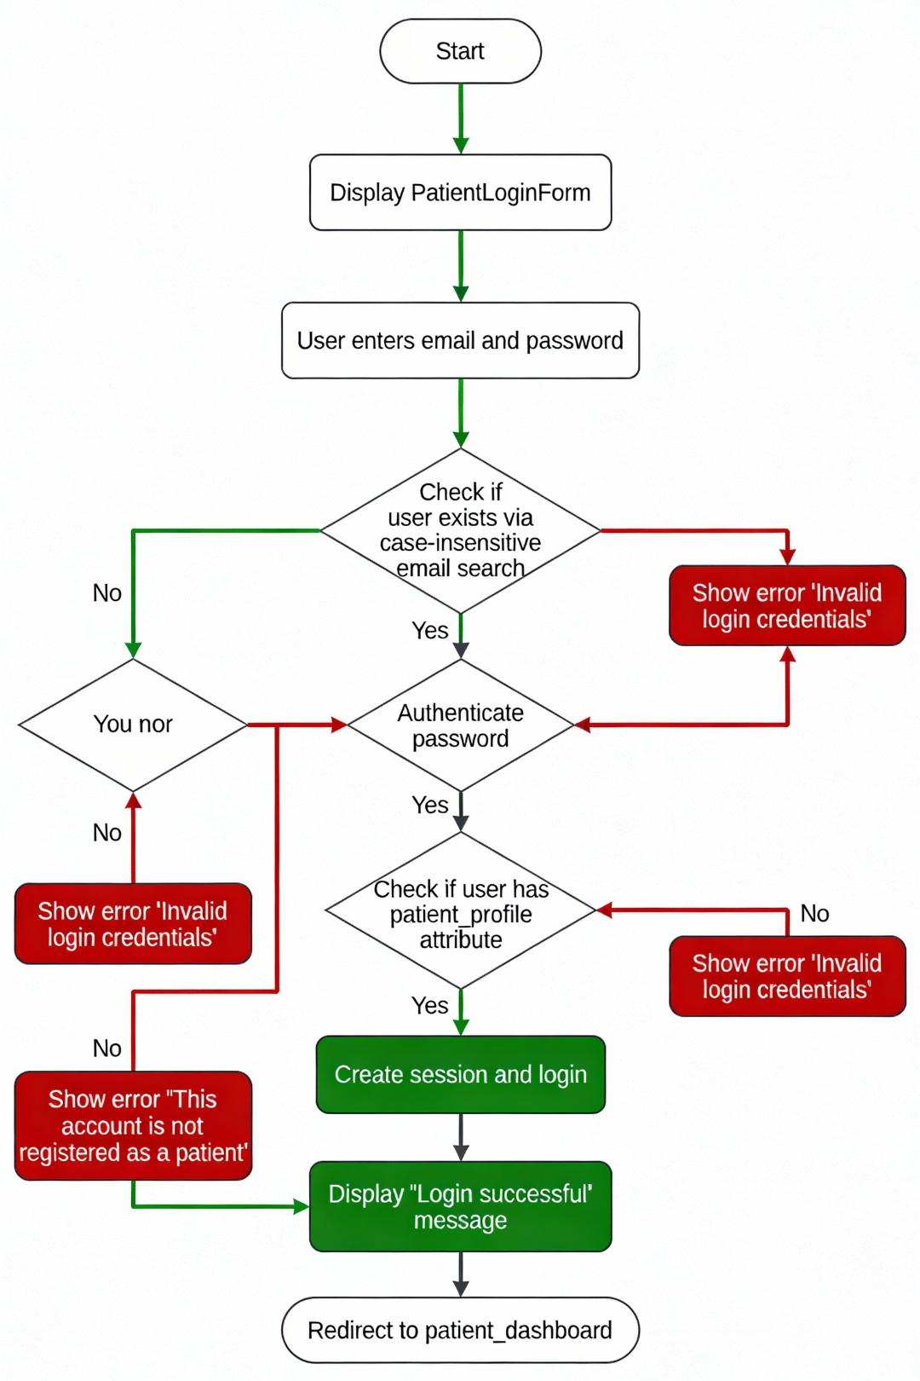

*Figure 4: Patient Login Authentication Flow*

## 3.3 Doctor Registration and Login

### Doctor Login Page

Similar to patient login with personalized welcome message upon successful authentication.

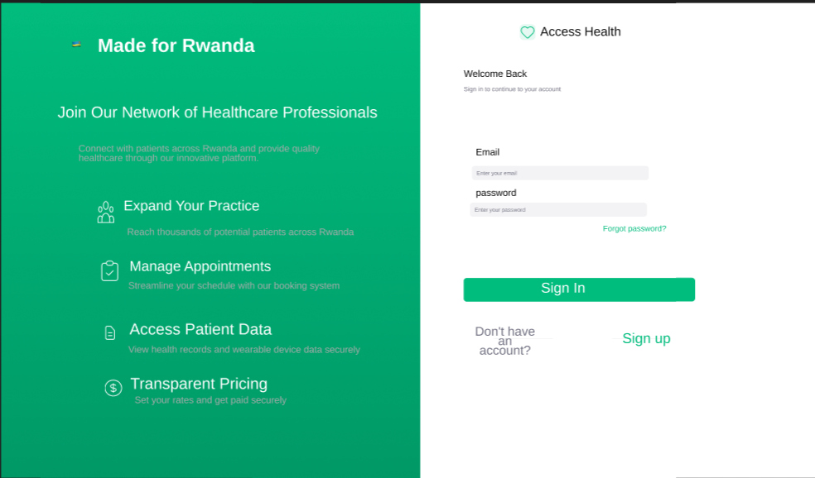

*Figure 5: Doctor Login Page*

### Doctor Registration Process Flow

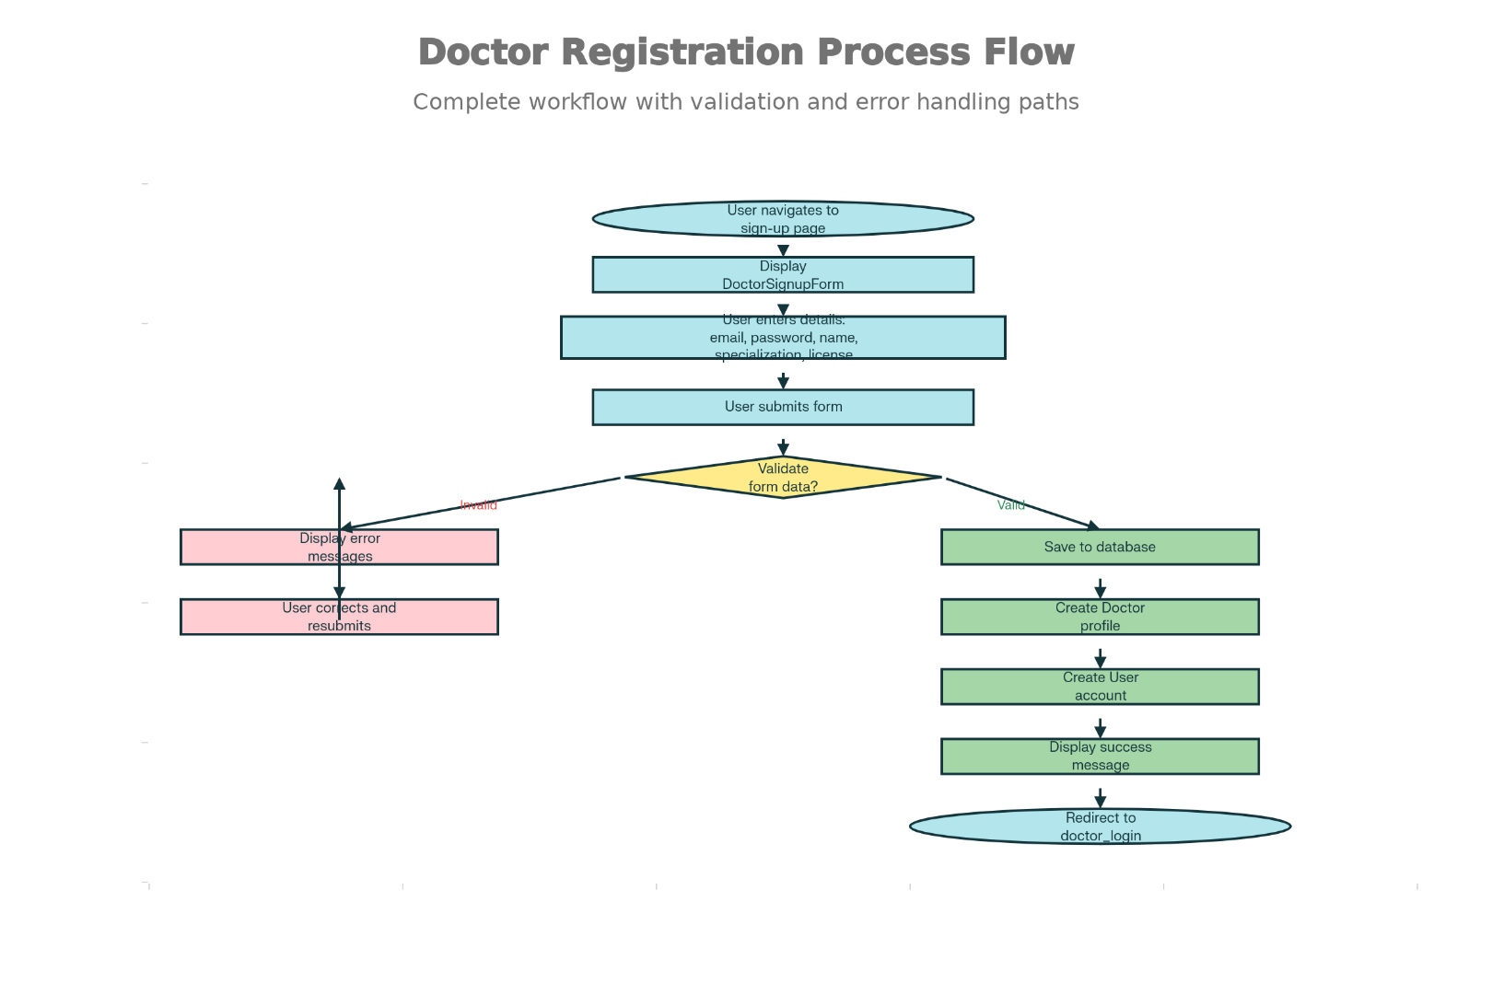

*Figure 6: Doctor Registration Process Flowchart*

## 3.4 Patient Dashboard

### Patient Dashboard View

Comprehensive health overview displaying vital signs, wearable device data, appointments, and notifications.

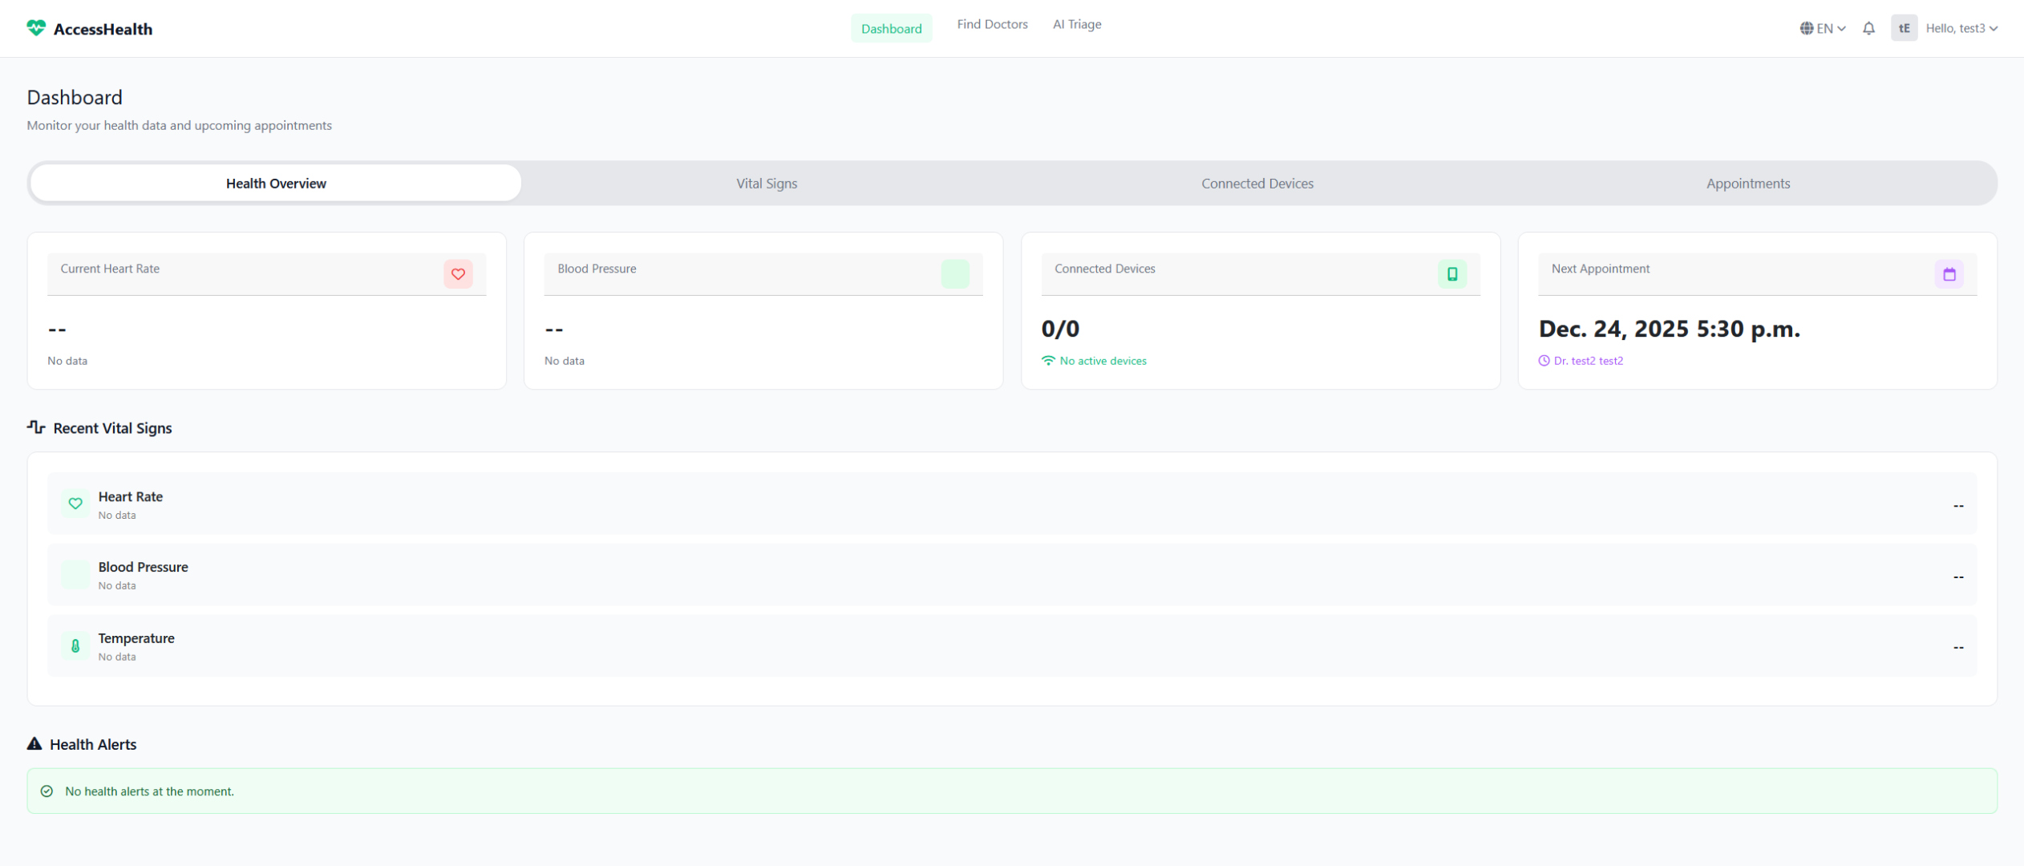

*Figure 7: Patient Dashboard View*

### Patient Dashboard Data Flow

Complete data retrieval process showing all database queries and data transformations:

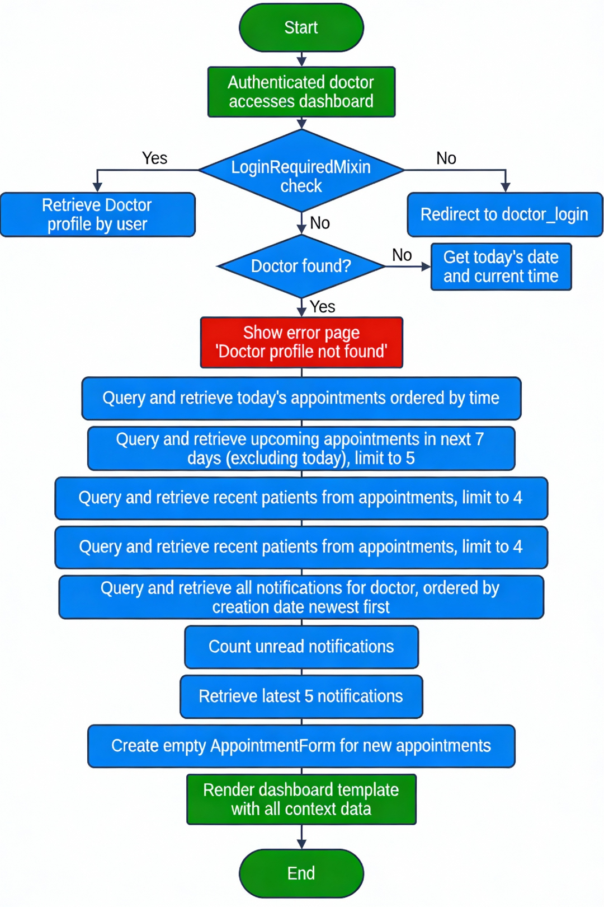

*Figure 8: Patient Dashboard Data Flow Diagram*

## 3.5 Doctor Dashboard

### Doctor Dashboard View

Personalized practice management interface displaying appointments, recent patients, and notifications.

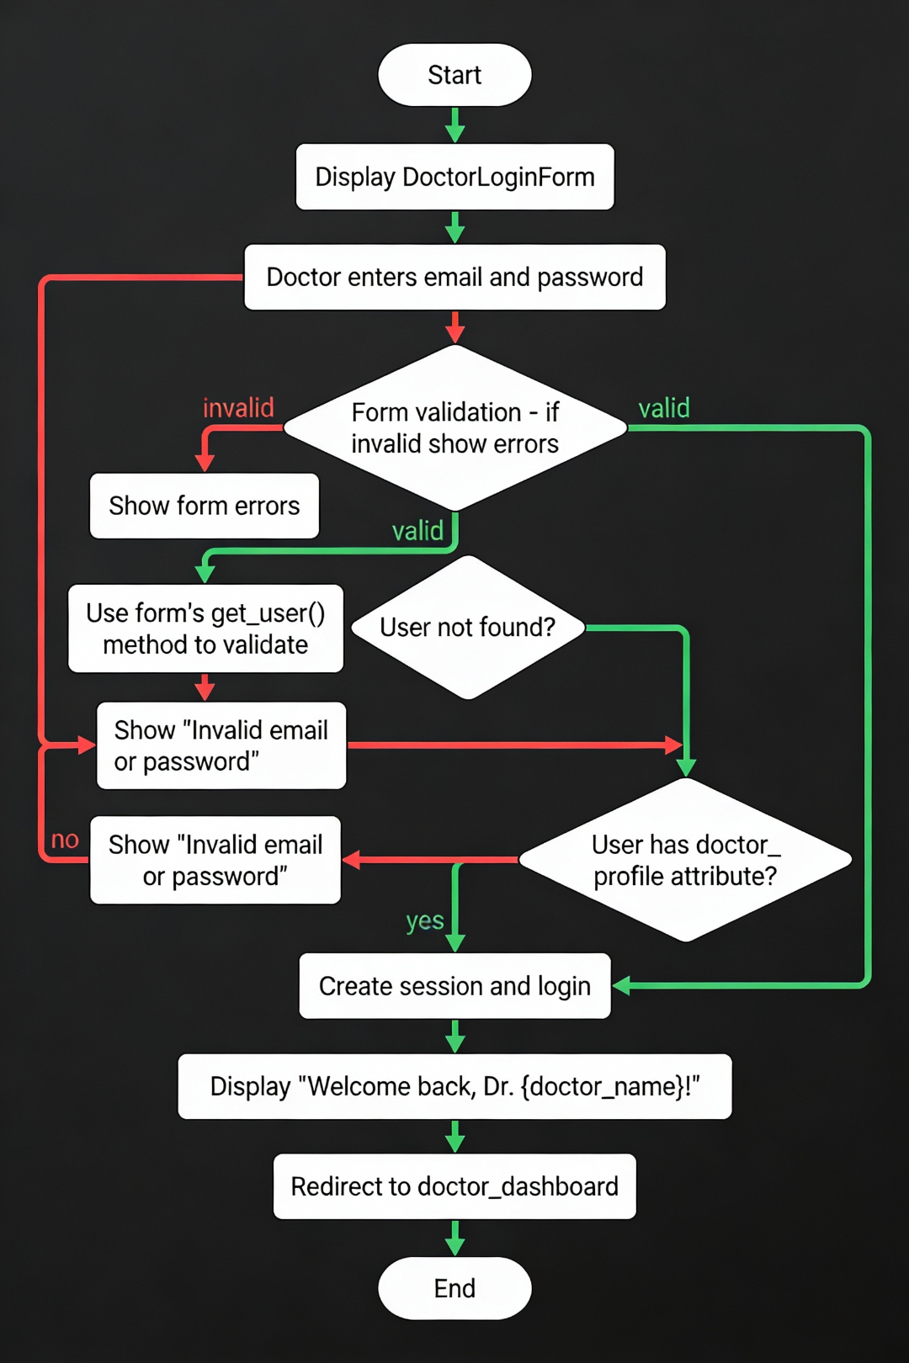

*Figure 9: Doctor Dashboard View*

## 3.6 Doctor Discovery and Search

### Doctor Discovery Interface

Comprehensive search and filtering interface allowing patients to find doctors by specialty, location, and consultation fees.

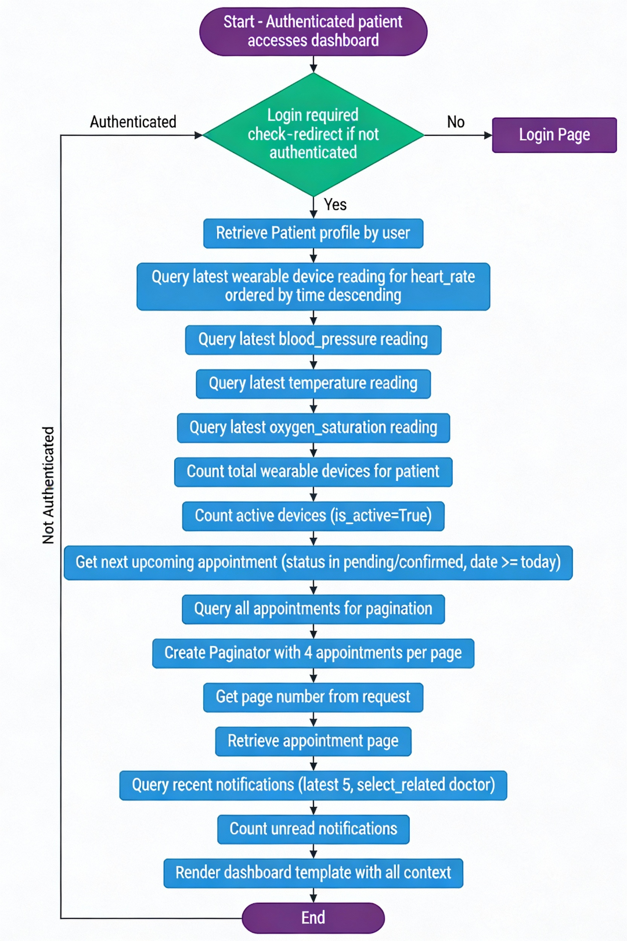

*Figure 10: Doctor Discovery and Search Interface*

## 3.7 Patient Appointment Booking

### Appointment Booking Workflow

Complete workflow showing appointment creation, validation, and confirmation process.

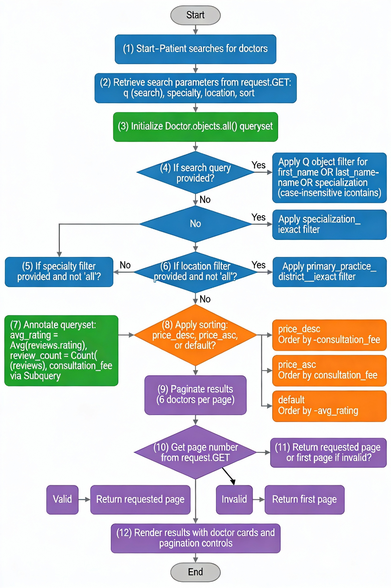

*Figure 11: Patient Appointment Booking Flow*

# Chapter 4. Conclusion and Recommendations

## 4.1 State of Implementation

AccessHealth has been successfully developed as a functional healthcare management platform implementing all core features specified in the requirements. Approximately 95% of planned features have been fully implemented and tested.

### Completed Features

* User authentication and role-based access control (100%)
* Doctor and patient dashboards with real-time data (100%)
* Doctor discovery with advanced search and filtering (100%)
* Appointment booking and management (100%)
* Notification system for users (100%)
* Wearable device integration framework (100%)
* Patient medical records management (100%)
* User profile management (100%)

## 4.2 Recommendations

For Future Development:

* AI-Powered Features: Implement symptom analysis and triage recommendations
* Telemedicine: Add video consultation capabilities
* Advanced Analytics: Dashboard for healthcare administrators
* Mobile Applications: Native iOS and Android apps
* System Integration: Connect with national health systems
* Automation: Background tasks for appointment reminders
* Payment Integration: Secure payment processing
* Appointment Reminders: SMS and email notifications

# Appendix

## A.1 Test Credentials

|  |  |
| --- | --- |
| User Type | Credentials |
| Patient | Email: tes3@gmail.com | Password: 12345678 |
| Doctor | Email: test2@gmail.com | Password: 12345678 |
| Admin | Email: admin | Password: admin |

## A.2 Technology Stack

|  |  |
| --- | --- |
| Component | Technology |
| Backend Framework | Django 5.2.8 |
| Database | SQLite (Dev) / PostgreSQL (Prod) |
| Frontend | HTML5, CSS3, Bootstrap 5, JavaScript ES6+ |
| Image Processing | Pillow 12.0.0 |

## A.3 Repository and Documentation

GitHub Repository: https://github.com/saa/accesshealth

Django Documentation: https://docs.djangoproject.com/

Bootstrap Documentation: https://getbootstrap.com/docs/